BIOLOGY EOC FINAL REVIEW NAME .
Concept #1: Data Analysis and Life Characteristics
1A) Which “Things” are biotic (organisms)? ________________

1B) Match each “Thing” number with the item below:
___ Oak tree
___ HIV
___ Earthworm
___ Diamond
___ Atmosphere
 | Thing 1 | Thing 2 | Thing 3 | Thing 4 | Thing 5
Composed of cells | No | Yes | No | Yes | No
Maintains  homeostasis | No | Yes | No | Yes | No
Moves on  its own | Yes | No | No | Yes | No
Acquires energy (respiration) | No | Yes | No | Yes | No
Can reproduce | No | Yes | No | Yes | Yes
Has DNA | No | Yes | No | Yes | Yes

Concept #2: Macromolecules (organic molecules)
FUNCTIONS – Use word bank
2E) Long term energy ___________
2F) Daily energy _______________
2G) Workers of the cell _________
2H) Genetics
and heredity ____________

Subunits – Use word bank
2I) Nucleotides _____________
2J) Amino Acids ____________
2K) Simple sugars ___________
2L) Fatty acids ______________

EXAMPLES of;
WORD BANK: Proteins, Carbohydrates,
Lipids, Nucleic Acids
2A) ___________ - fats, oils, waxes
2B) ___________ - glucose, starch, saccharide
2C) ___________ - DNA & RNA
2D) ___________ - Lipase, Insulin, hemoglobin

Concept #3: Cells composition and type comparison
Place a check in the appropriate boxes indicating the type and presence of each.
Draw a line connecting word to place in picture.
Ribosomes
DNA
Cell Wall
3A) CELL TYPE: ___________________
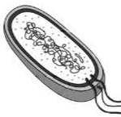
Thinglink.com
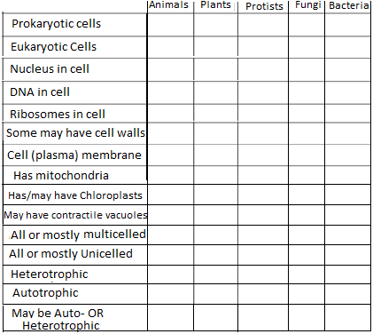
Draw a line connecting word to picture.
Nucleus
Cell wall
Mitochondria
Ribosomes
Chloroplast
Draw a line connecting word to picture.
Nucleus
Cell membrane
Mitochondria
Ribosomes
3B) CELL TYPE: ____________________
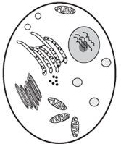
3C) CELL TYPE: _____________________
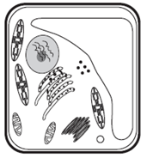
Concept #4 Cell Specialization and Differentiation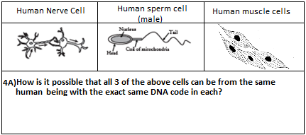
4B) Which of the labeled cells would be considered a
stem cell? _____
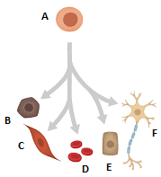
4C) Cells B-E could best be described as
A) Stem cells B) Specialized Cells ?

Concept #5 Cell Transport (active vs. passive transport, diffusion and osmosis) & Homeostasis
Complete the rows below by circling the correct answer in boxes A, B, C, D, F. Fill in the blank for box E.
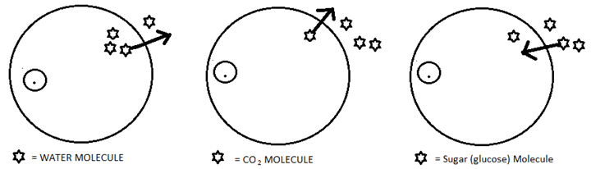
A) 5A) PASSIVE or ACTIVE  transport | 5C) PASSIVE or ACTIVE  Transport? | 5E) PASSIVE or ACTIVE  Transport?
5B) OSMOSIS or DIFFUSION | 5D) This will require _______ | 5F) OSMOSIS or DIFFUSION

Concept #6 Energy Flow
6A) The top half of the diagram to the left shows the process of ____________________.
6B) The bottom half of the diagram to the left shows the process of ____________________.
6C) If an organism is only obtaining 2 ATP from sugar without oxygen present, then that is known as _____________________________.
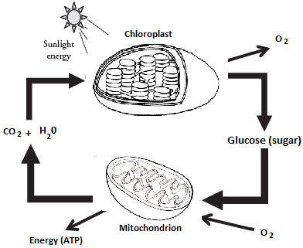
6D) Write the words below in their likely place in the pyramid.
Autotrophs, Carnivores,
Omnivores, Herbivores.

6E) Place an asterisk (*) in the rows of the pyramid where organisms would do
cellular respiration.

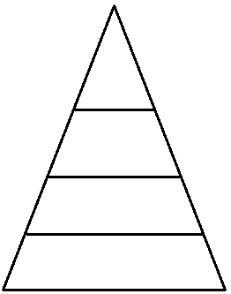

Concept #7 DNA, DNA replication, and the Cell Cycle
7F) Cell division (of body cells) is known as _____________________.
This is how you have grown and healed (tissue repair).
Name the correct phase of mitosis pictured.
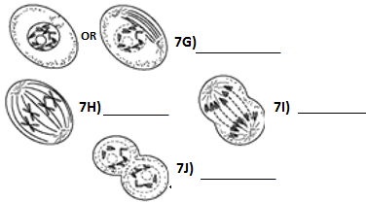
7B) How many total nucleotides make up the DNA section to the left? ___

7C) A DNA section that codes for a protein is a _____
7D) DNA replication (DNA synthesis) MUST occur before the cell divides. That phase of the cell cycle is known as _________________________________
7E) Complete DNA replication below by writing the correct bases below the line.
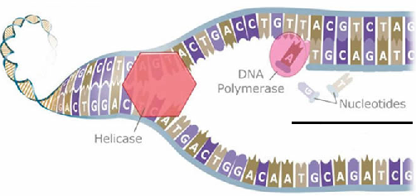
7A) Complete the other half of the DNA strand below by writing in the nitrogen bases.
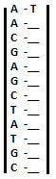

Concept #8 Protein Synthesis
Complete 8A*, 8B, and 8C using the given codes and codon charts below. *You may just write the first 3 letters of the amino acid.
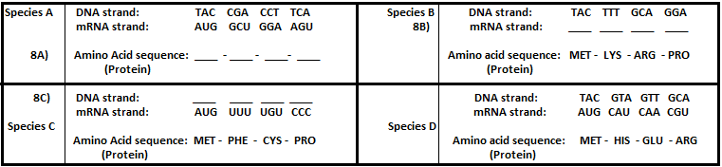
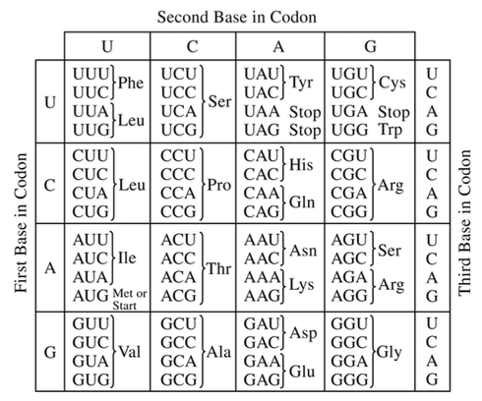
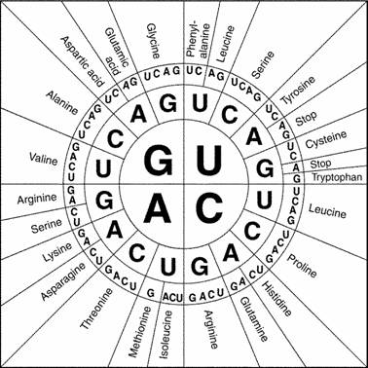

8D) The more similar the amino acid sequences (proteins), the more similar the species.
Of the 4 species above, which two species are most closely related? _______________
Concept #9 Cell Division

-4 cells produced
-2 cells produced
-Genetically identical
-Genetically different
-Asexual
-Cloned cells produced
9A) Write the following terms in the correct place within the Venn Diagram;

-Cell Division
-Gametes
-Somatic
-Diploid
-Haploid
-Crossing over
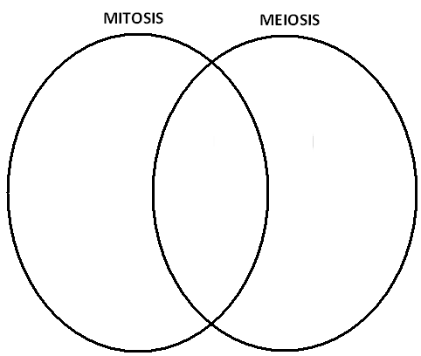
10h. Is it possible for two parents with
Type-A blood to have a child with Type-O?
CIRLCE ONE: Yes / No
10i. Using a Punnett square, prove your circled answer above.

Concept #10 Genetics
10f. Cross a purebred free ear-lobed man with an attached ear-lobed woman.

10g. What are their odds of having an attached ear-lobed child? ______%
10. Genetics Vocabulary
Write down;
a) A Homozygous Recessive Genotype ______
b) A Homozygous Dominant Genotype ______
c) A Heterozygous Genotype ______
d) A human phenotype _________________
e) MATCHING: Draw lines connecting “like” concepts.
HOMOZYGOUS HYBRID
HETEROZYGOUS PUREBRED

10J. For hemophilia (sex-linked), cross a normal male with a carrier female.

10k. What are their odds of having hemophiliac child? ______%

10L. Assume the parents in question 10J have 4 children, 2 boys and 2 girls, that match the probabilities of hemophilia as shown in the Punnett square.
DRAW the pedigree below of the 6 person family in #10J.

10m) The image below is a __________.
10n)The disorder shown is __________.
10o)The sex of the individual is _______.
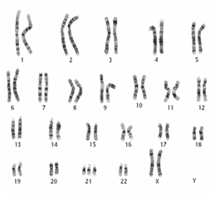
monashultrasound.com

Concept #11: Biotechnology
11a. Gel Electrophoresis
Circle the suspect whose
DNA was left at the crime scene.
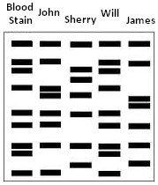

11C: TRANSFORMATION Label 11C-11E.
Word bank: PLASMID, RECOMBINANT DNA, HUMAN CELL, BACTERIAL CELL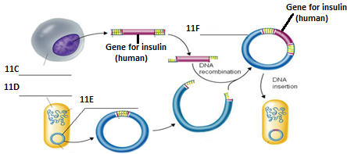
pmgbiology.wordpress.com
11b) Who is the BABY’s biological father?
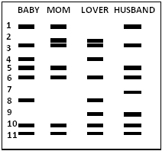

Concept #12: Natural Selection and Evolution
12a) Endosymbiosis is a theory that ___________ cells were on the Earth first and through “absorbing” other cells, became a cell with functioning organelles and a nucleus…which would be a _________________ cell.
ASSUME the bacteria below were sprayed with an antibiotic on DAY 1.
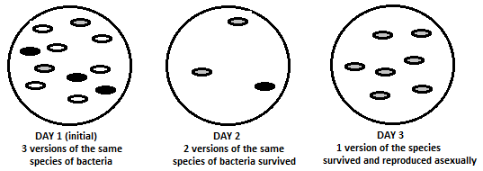
12b) What concept does the above 3 day sequence of a bacteria population demonstrate? ______________
12c) Which bacteria were most immune/resistant to the antibiotic (circle one)? White Grey Black
12d) Which bacteria were least immune/resistant to the antibiotic (circle one)? White Grey Black
12e) Bacteria reproducing asexually is known as ____________ and is similar to human cells performing 12f)__________
12g) How is it possible that some bacteria of the same species survived and some did not?

Concept #13: Classification diagrams (Dichotomous Keys, Cladograms, and Phylogenetic trees)
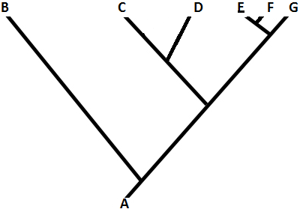

13c) Which two species are most closely related? ____

13d) Which Species would be considered the common ancestor? _____
Concept #14: Human Impact
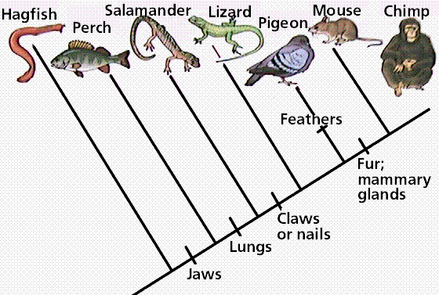
13b) List the organism(s) that has/have jaws and lungs, no fur, no mammary glands, no feathers.

_________________________

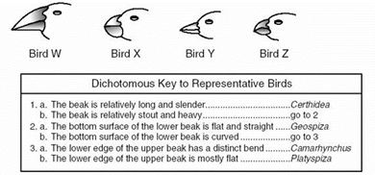
13a) What is the Genus name of Bird X?
_____________

For each action listed (14a-14i), write the potential outcome numbers in the blanks.
ACTION
____________ 14a) Fertilizing the yard
____________ 14b) Driving a vehicle
____________ 14c) Eating food you did not grow or raise yourself
____________ 14d) Burning trash
____________ 14e) Throwing waste in the trashcan
____________ 14f) Eating eggs or meat
____________ 14g) Building a house
____________ 14h) Introducing a non-native (invasive) species
____________ 14i) Flushing the toilet

POTENTIAL OUTCOME/RESULT

1) Habitat loss
2) Loss of biodiversity
3) Acid rain
4) Greenhouse gasses
5) Algal blooms

Concept #15 - Carrying capacity and limiting factors
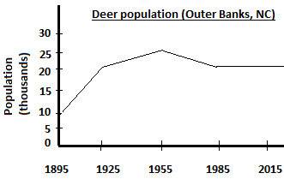
15a) In what year did limiting factors start slowing the deer population growth? ______________

15b) What is the NC Outer Banks likely current carrying capacity for deer? _____________

15c) What are some potential causes for the decline in the deer population from 1955-1985?

Concept #16 – Cycles and tying together concepts
16a) Draw and label a diagram below which ultimately will show the following concepts: Carbon Cycle, Water cycle, Nitrogen Cycle…Cellular Respiration, Photosynthesis, Decomposition, Nitrogen fixation, runoff, and energy movement through a food chain (or web).

